Abstract:
Online Bus pass generation is useful for students who are facing problems with the current manual work of bus pass registration and renewal. The students need to register by submitting their details through online. After registration an OTP code will be send to student’s mail. The administrator will verify the student details and if they are satisfied they will approve bus pass. The pass will be generated and send to student’s mail. The student can login with their college idno and password and then renewal can be performed.

INTRODUCTION
This project is created to provide “safe, reliable, saving, efficient and affordable” services for user. This idea would help the user in a better way. As per the previous system the user had to do each and every process manually, but this system helps user to make the work bit faster. The user can then take print out of this bus pass from their mail id and use them. The bus pass will be differ for different types of users. In this bus pass, all the required details such as candidate name, address, date of birth, mail id, name of the school(government/private), validity period, amount paid (free for government school students) and photo copy of the candidate are provided. Instead of school details, working organization details will be provided in employees bus pass. The renewal process can be done either monthly or yearly as per user wish. Based on that renewal period amount will be deducted.

Literature Survey
EXISTING SYSTEM
In the existing system bus pass registration and renewal process are carried out manually. The person has to visit the counter and have to submit the details and then they have to wait for approval. For each and every process there is time limit specified if the person fails to go on time then all the transactions will be cancelled. In this existing system was used to bus details maintain through file. And after bus information are stored to computerize. The Project Metrics has to enter all the details of project, documents, and tasks. And, also the maintenance team information and also efforts estimation. For this purpose the organization maintain the size of the document, source code and update the information about team member’s details manually. Which is much of time consuming process and more importantly it is error prone. At present system bus pass collect from depot very rare one. User can facing lot of problems.
Disadvantages
• It is time consuming
• It consumes lot of manpower to better results
• It lacks of data security
• Retrieval of data takes lot of time
• Percentage of accuracy is less
• Reports take time to produce

PROPOSED SYSTEM
The proposed system overcomes the drawbacks in the existing system. In the proposed system user register their details through online and get their unique username and password for further processing. The bus pass will be differ for different types of users. In this bus pass, all the required details such as candidate name, address, date of birth, mail id, name of the school (government/private), validity period, amount paid (free for government school students) and photo copy of the candidate are provided. Instead of school details, working organization details will be provided in employees bus pass. The renewal process can be done monthly as per user wish. Based on that renewal period amount will be deducted.
Features of the Proposed System
• To make accuracy and efficient calculations.
To provide proper information briefly
• To provide huge maintenance of records
• Flexibility of transactions can be completed in time
• Easily bus pass apply through online.

Syatem ARCHITECTURE DIAGRAM:
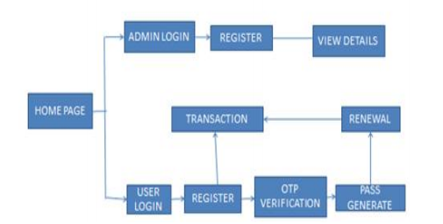

Functional Requirements
DBPS Structure:
In this system user first visit to the site or application, then the user get registered on the application by entering mobile no. Or email and password. This will register user on the application then user logins in to the application. Then two options will be displayed on screen first apply for new pass or login. After selecting login option first form will be displayed on the screen and user has to fill all the required information in that form and click on submit button. Then payment options like Credit card or Debit card will be displayed. As soon as payment is completed, user is provided with the soft copy of pass containing a QR code in which information is field by user in the form which is encrypted in it. Soft copy of bus pass is printed with QR code Basic information like ID, Name of the user, Birth date and Photograph. He or she can take a printout and show to the conductor at the time of journey. Bus conductor checks validity of pass and identification of user. In DBPS system display notification when the pass is near about to expiry date so that user can renew it as fast as possible. DBPS system reduces human mistakes and time delay.

Renew Bus pass:
Most of the time user forgot the expiry date of their Bus pass and date in to the bus with the expired bus pass and it will results in to inconvenience of user. But this system provides an effective solution on this problem means when pass is about to expire before two or three days expiry date, a notification appears on the users mobile screen. Because of the reminder (Notification) user may renew the pass for renewing pass user login on to their phone account with the help of user name and password. In that user has to choose renew option and the application directs the user to payment screen when user pay the payable amount using Credit or Debit card. This process takes few seconds and application connects to the government server and updates the renewal data.

Security and tracking:
Now a day’s women safety is big issue. Most women in urban India or no strangers to the worried ‘Text me when you reach, Ok?’ from family member especially if they are travelling back home late at night. This system provides safety options for women means when the pass of any women is scanned the message will goes to her guardian. The message contains journey details and time. This will notify to the guardian that their daughter or wife is safe and women need not to send reach message to their guardian. In case of card is loss or misplace then we can track the card.

Data analysis:
All the data is stored in government server. All the data like customer data, payment related data and admin side data is stored in the government server database. Government server database is a centralized data base. All the admin or conductors report to the centralized database.

4.4.3 Non-Functional Requirements
- Response Time: Since it is a general application the response time depends on the seek time and access time of the location which plays the major role in this application.

- Real-Time: The software will provide up-to-date information, not limited by the user’s internet speed. As the data required by each user is cached locally and only changes to it are synced back from the server

- System Resource Consumption: Resource consumption of this application should not reach an amount that it crashes the system. The application should be capable of operating in the background.

- Workload: The workload in this system can be defined in two scenarios where the administrator has the option for to delete the junk and redundant files from the remoter computer. Since the data present in the remote computer may vary and if the data is more than the workload for deletion of junk and redundant files takes time.

- Scalability: As the system developed in a systematic manner hence the application is flexible and adding up some more feature to the existing application will not be an issue as it has been developed using java

- Reliability: Since the system provides option for choosing the type of operation to be performed on computers i.e. the administrator can select according to his will and wish whether he wants to delete the junk or the redundant files.

- Usability: The GUI is user friendly hence it is in very easy to use the software.

- Maintainability: The software should be written clearly and concisely. The code will be well documented. Particular care will be taken to design the software modularly to ensure that maintenance is easy. Also the system is to be developed using open source technologies, thus easing maintenance work in future.

Modules
- User: Using this system User can
  - Fill bus pass online using web application and android application
  - Register for the pass, by submitting the basic details online initially
  - login to the system by entering login id & password that is providing at the time of registration
  - Submit the required documents online
  - Extend the validity every time when the pass expired
  - Issue smart cards and recharge cards
  - Change their password
- Admin: Using this system admin can
  - View all users details and balance system through its login
  - Generates reports and manage the whole system.
  - Manage profile of user
  - Change or modify user right
  - Manage the different pass schemes,
  - Verification of online registration passes
  - he/she can check the history of pass of any user for verification

3) Handicapped : Using this system User can
  - Fill bus pass online using web application and android application
  - Register for the pass, by submitting the basic details online initially
  - login to the system by entering login id & password that is providing at the time of registration
  - Submit the required documents online
  - Extend the validity every time when the pass expired
  - Issue smart cards and recharge cards
  - Change their password

SYSTEM REQUIREMENTS

3.1 Software Requirements:

Web Server : WAMP Server
Web Browser : Google chrome or Internet Explorer
Front-End Tool : HTML
Client side Tool : Java Script
Server side Script : PHP
Back-End Tool : My SQL
IDE : Notepad, Dream viewer

3.2 Hardware Requirements:
Processor : Intel Core i3
Processor Speed : 2.00GHz to 1.99GHz
RAM : 2 GB RAM
Hard Disk : 80 GB and above
System type : 64-bit operating system, x64-based processor
Keyboard : Standard 104 enhanced keyboard

DFD

0 Level

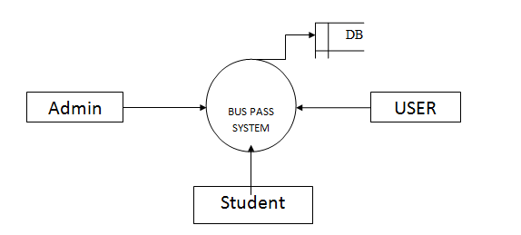

1 Level

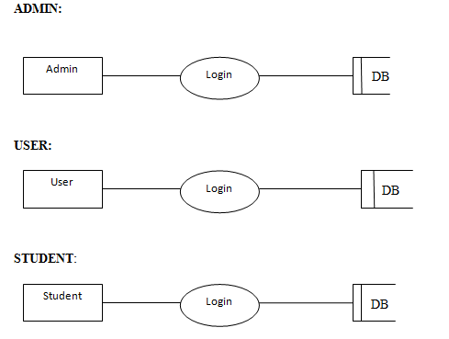

2 Level

